**Specialist Mathematics Units 3 & 4**

**Test 3 2017**

**Calculator Free Section**

**Name: __________________________ Score: _____ / 28**

**No calculators or notes are to be used.**

**Access to approved Mathematics Specialist formulae sheet is permitted.**

**Simplify answers where possible. Time limit = 30 minutes.**

**1. [ 5 marks ]**

Points A (-1, 2, 3), B (x, y, -1) and C (14, -4, -9) are collinear. Determine the values of x and y, and state the vector equation of this line.

**2. [ 5 marks ]**

Find the vector equation of the plane in the form **r.n** = k passing through the lines with equation:

**r** = <1,1,1> + <2,7,1> and **r** = <4-, 2+7, 7-3>

**3. [ 3 marks ]**

State the Cartesian equation traced by the point P with position vector **r** = *t 2* ***i* +** *t* ***j***, where t represents time. Sketch the path on the axes below, indicating the direction of motion.

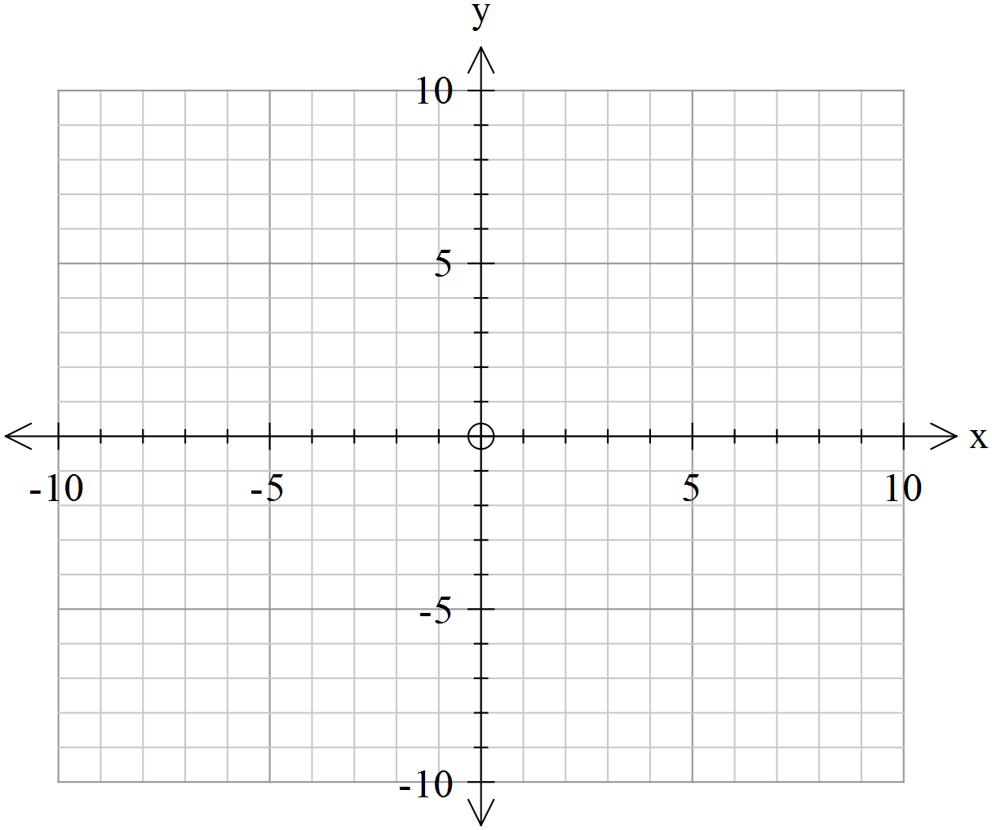

**4. [ 9 marks: 4, 1, 1, 2 ]**

Determine the possible values of *m* so that the following system of equations has

**a)** a unique solution,

**b)** no solution,

**c)** or more than one solution.

*2x* + *y - z* = *3*

*mx* - 2*y* + *z*  = 1

*x* + 2*y + mz* = -1

**d)** Using geometric planes, sketch and/or describe two different situations where a system of linear equations will have **no** solutions.

**5. [ 3 marks ]**

State the vector equation of the sphere with the Cartesian equation



**6. [ 3 marks ]**

Prove the property:

“If **a** and **b** are non-zero vectors then **a** x **b** = 0 means **a** is parallel to **b**.”

END OF PAPER

**Specialist Mathematics Units 3 & 4**

**Test 3 2017**

**Calculator Section**

**Name: _______________________ Score: _____ / 29**

**Calculators allowed and 1 page of A4 notes, writing on both sides.**

**Access to approved Mathematics Specialist formulae sheet is permitted. Time limit = 30 minutes**

**7. [ 7 marks: 4, 3 ]**

**a)** Determine the position vector of the point where the line meets the plane .

**b)** Determine the angle between the line and the plane in degrees to 1 decimal place.

**8. [ 6 marks ]**

Two rockets are moving at a constant velocity in straight lines. The first starts at (2, 2, 1) and has velocity (3, -1, -7) and the second has velocity (2, 1, -5), starting from (2, -3, 2). Show whether their paths cross and determine if they collide.

Give the coordinates of the point of crossing or collision.

**9. [ 7 marks ]**

In order to bring about a prison break a grappling hook is fired from a crossbow from a position level with the base of a wall 500m away. Two-and-a-half seconds later the grappling hook just clears the wall. If the wall is 6 m high, calculate the initial velocity to the nearest m/s and the projection angle of the ball-bearing to the nearest degree.

Assume gravity to be 9.8 m/s2. It may help to draw a diagram first.

**10. [ 9 marks: 2, 2, 2, 3 ]**

The velocity vector of a particle P, at time *t* seconds after projection from < 0, 0, 0 > is given by **v***(t)* = < *t -1*, *0*, *t – t 2* > where the components are measured in cms-1.

**a)** Determine when P is instantaneously at rest.

**b)** Calculate the distance travelled by P between the time it starts moving and when it is instantaneously at rest.

**c)** What is its position when it comes to rest ?

**d)** Determine when, if ever, the velocity is perpendicular to the acceleration.

END OF TEST